1. Read an bmp image from a location in an harddrive, flip the image up-down and left-right.

a = imread('lena512.bmp');

subplot(2,2,1);
imshow(a);

b = flipud(a);
subplot(2,2,2);
imshow(b);

c = fliplr(a);
subplot(2,2,3)
imshow(c);

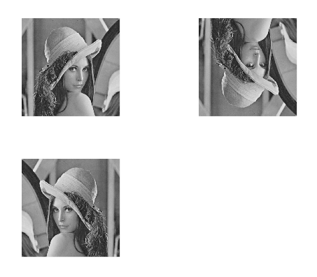

2. Display the intensity of pixel in position (20,0) (511,511),(0,0) and relate it with picture

a = imread('/home/linuxsagar/Desktop/IP/Practical/Lab1/lena512.bmp');

p= a(20,0)
output: error: subscript indices must be either positive integers less than 2^31 or logicals

p = a(511,511)
output: p = 105

p = a(0,0)
output: error: subscript indices must be either positive integers less than 2^31 or logicals

3. Get the size of the image.

[row,columns]=size(a)

output:
row = 512
columns = 512

4. Writing an image to graphics file

original=imread('lena512.bmp');
imwrite(original,gray(512),'changed.bmp');

OUTPUT:

original.bmp
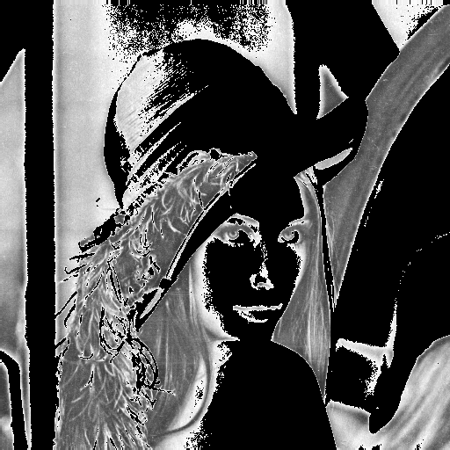changed.bmp

d) Create an array of size 512 x 512 and assign values 1-512 to elements of rows. Then display it.:

for i = 1:1:255
for j = 1:1:255
a(i,j) = j;
end
end

1) Display image created in d by a using function imshow(a).

Output:
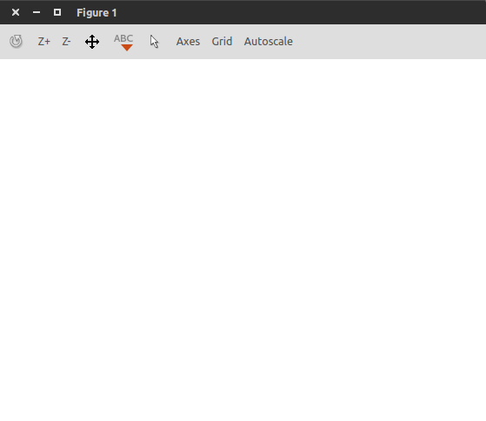

2) Display image created in d by a using function imshow(a,[0 255]);

Output:
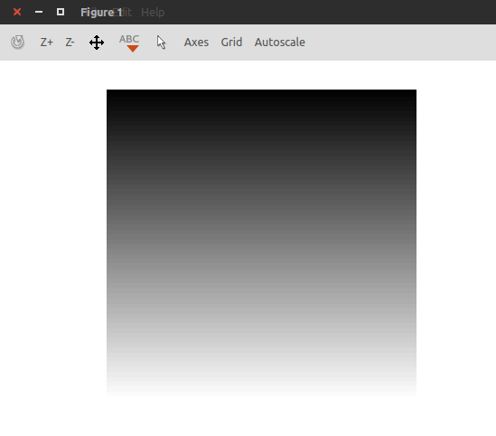

g) Observe the difference

for i = 1:1:255
for j = 1:1:255
a(i,j) = j;
end
end
imwrite(a,'first.bmp')
imwrite(a,gray(256),'second.bmp');

Output:
first.bmp
 second.bmp

